REQUEST FOR LEUKAPHERESIS
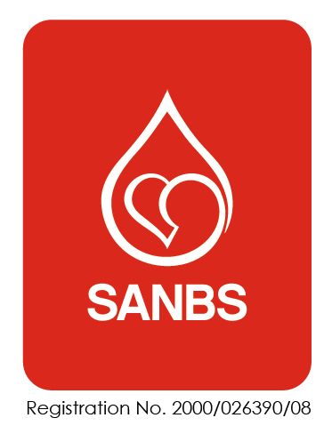

Please print legibly as this is a Medico-legal document.
I hereby request the South African National Blood Services to perform a Leukapheresis (or series of
procedures) on the following study participant.

Study Participant
Date of Birth |  |  |  |  | Gender |  |  |  |  |  | Height
Age |  |  |  |  | ID No |  |  |  |  |  | Weight
Diagnosis |  |  |  |  |  |  |  |  |  |  | ICD CODE
Hospital |  |  |  |  |  | Hospital Number |  |  |  |  | Ward
Medical Aid  Society |  |  |  |  |  |  |  |  | Primary member/  dependant
 | Medical Aid No: |  |  |  |  |  | Dependant  Code
Address
Contact No  (Home) |  |  |  | Work |  |  |  |  |  |  |  | Cell
Procedure Required |  |  |  |  |  |  |  |  |  |  |  | ABO and RH
Central line  (indicate) | Size |  |  | Type |  |  |  |  |  |  |  | Site
Allergies
First Procedure  (date) |  |  | Frequency  (indicate) |  |  |  |  | Daily |  |  |  | Alternate  Day |  |  | Other:
Blood Volume to be processed |  |  | Estimated Number of Procedures

Laboratory Results

Date of Results (no older than 72 hours)
*Haemoglobin (Hb) |  | *Potassium (K) |  | Neutrophil count /%
*Haematocrit  (Hct) |  | Urea |  | Lymphocyte  Count/%
*WCC |  | Creatinine |  | Monocyte count/%
Platelets |  | GFR |  | Basophil count/%
*Corrected  Ca++ |  | GCS |  | Eosinophil count/%
Ionized Ca++ |  | GBS ds |  | RVD | + | -
*Mg ++ |  | pO2 |  | HBV | + | -
Other |  | FIO2 |  | HCV | + | -

*Compulsory Blood Tests
Potassium, Calcium and Magnesium levels: may be reduced by the apheresis procedure.
Haemoglobin level: required for all apheresis procedures.
Haematocrit and Leucocyte count: required to establish the interface on the day of the procedure.
These tests are ideally performed on the day of/ day prior to the procedure and cannot be older than 72 hours.

Study Participant Details |  | DOB/ ID Number

Medication on first day of procedure

Medication | Dosage | Route | Frequency

- Please notify the Apheresis Staff if the procedure is cancelled or the study participant’s condition
changes.
- Please note completion of the necessary documentation is a medico-legal requirement and any delays in the completion of the paperwork will result in delays in the procedures.

CHECKLIST
Study Participant details | Weight (daily for the duration of procedures).
Documents | Completion of a consent form.
Documents | Completion of a request form
Ward/ cubicle | Working light source
Ward/ cubicle | Working water supply
Ward/ cubicle | Working electricity supply
Ward/ cubicle | Working suction supply
Central venous catheter (CVC) | If subclavian or internal jugular veins,  CXR confirmation of the position of CVC and exclusion of pneumothorax.  NOTE: It is the attending physician’s responsibility to ensure the correct placement of the central venous catheter.
Blood results: Daily | FBC.
Blood results: Daily | Calcium.
Blood results: Daily | Magnesium
Blood results: Daily | U&E and creatinine

STANDING ORDERS FOR EMERGENCY TREATMENT OF ADVERSE EFFECTS DURING LEUKAPHERESIS

Standing orders for the treatment or prevention of adverse effects during a Leukapheresis are reviewed by the
Apheresis Director. The Apheresis Staff and/or the Apheresis Director and the attending physician must be notified,
as soon as possible, of any adverse reaction that occurred after the procedure.

            - Citrate toxicity or hypocalcaemia
  - Study participants that have Leukapheresis performed should have ionized calcium or a total and corrected calcium level tested.
  - In a study participant presenting with an ionised calcium level less than 1 mmol/L or a corrected calcium count less than 2 mmol/L, intravenous calcium should be administered (e.g. administer 1 ampoule calcium gluconate IV over three minutes and administer 1 ampoule calcium gluconate 10% in a 200ml saline over 2-3 hours during the procedure).
  - A study participant presenting with an ionised calcium count of 1.1 mmol/L or corrected calcium count of less than 2.15 mmol/L, administer 1 ampoule calcium gluconate in a 200ml saline over 2-3 hours during the procedure.
  - If a study participant presents with symptoms of mild hypocalcaemia, administer 1 gram of oral calcium gluconate (e.g. Calcium Sandoz). The dose can be repeated PRN x2.
  - If a study participant develops moderate to severe hypocalcaemia, administer 1 ampoule of calcium gluconate 10% in a 50ml saline solution over 10 minutes. Alternatively, administer calcium by slow intravenous (IV) push.

Study Participant Details |  | DOB/ ID Number

Agreement by attending physician designate
I have medically examined the study participant and undertaken the relevant laboratory investigations and I consider the study participant will tolerate the procedure without any significant untoward reaction.
I permit the SANBS Registered Nurses to swap the draw and return lines of the central venous catheter if necessary, to obtain adequate flow rates during the apheresis procedure.

I understand that the technical procedure is being undertaken by the staff of SANBS. I have
made arrangements for emergency medical care should it be necessary. I authorise the administration of medication routinely used during this type of procedure. I understand that I as the attending physician/designate primarily remain responsible for the medical management of the study participant and must be available for consultation during the leukapheresis, or in the event of any untoward reaction.

Any medical waste generated from the clinical apheresis procedure will be managed according to the clinical
facility waste management guidelines.

______________________________________ _____________________________________
Name of Responsible Physician/Designate Signature

_______________________________________ ______________________________________
Practice Number Contact Number

_______________________________________
Date

